**Experiment 7**

**Q1) Write a script to reverse number passed using positional parameter.**

**Code:**

#!/bin/bash

a=`expr $1`

num=`expr $a`

d=0

until [ $num -eq 0 ]

do

r=`expr $num % 10`

b=`expr $d \* 10`

d=`expr $b + $r`

num=`expr $num / 10`

done

echo The reverse of a number is: $d

**Output:**

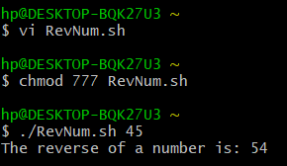

**Q2) Write a script to list all files in a directory using for loop.**

**Code:**

#!/bin/bash

echo Enter a directory:

read dire

cd $dire

for dire in `ls`

do

echo $dire

done

**Output:**

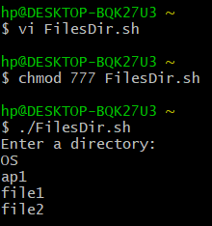

**Q3) Write a script to find largest value passed using command line.**

**Code:**

#!/bin/bash

if [ $1 -gt $2 -a $1 -gt $3 ]

then

echo "$1 is greater"

elif [ $2 -gt $1 -a $2 -gt $3 ]

then

echo "$2 is greater"

else

echo "$3 is greater"

fi

**Output:**

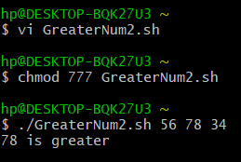

**Q4) Write a script to search a particular file and rename it.**

**Code:**

#!/bin/bash

dire=`expr $1`

a=`expr $2`

if [ "$(ls | grep $dire)" = "$dire" ]

then

mv $dire $a

else

echo File does not exist.

fi

**Output:**

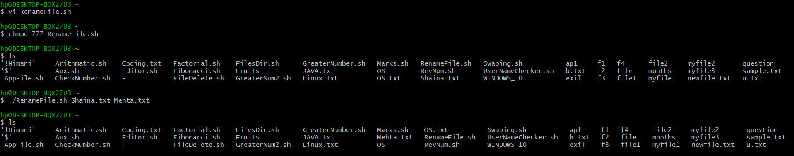

**Q5) Write a script to print Fibonacci series.**

**Code:**

#!/bin/bash

read -p "Enter a number: " a

b=0

c=1

echo $b

echo $c

d=`expr $a - 2`

for ((i=0; i<$d; i++))

do

e=`expr $b + $c`

echo $e

b=`expr $c`

c=`expr $e`

done

**Output:**

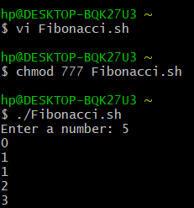

**Q6) Write a script to create and delete directory using case.**

**Code:**

#!/bin/bash

echo Main Menu

echo 1. Make Directory

echo 2. Remove Diretory

read -p "Enter the choice: " ch

case $ch in

1)

read -p "Enter the name of the directory to be created: " mdire

mkdir $mdire

;;

2)

read -p "Enter the name of the directory to be deleted: " remdire

rmdir $remdire

;;

*)

echo Invalid Choice

;;

esac

**Output:**

